MOTORGUARD DIGITAL TWIN
Hierarchical Meta-Fusion Predictive Maintenance Framework
for Squirrel-Cage Induction Motors Using a
Digital-Twin-Inspired Simulation Environment

Publication Results & Revised Metrics — IEEE Revision
UMaT Year 4 Capstone Project | May 2026
Target: IEEE Transactions on Industrial Electronics (TII) / IEEE TIA

PRIMARY RESULTS AT A GLANCE
5-Fold CV F1-Macro | ROC-AUC (OvR Macro) | Accuracy (5-Fold CV)
0.9089 ± 0.0134 | 0.9803 ± 0.0042 | 90.89% ± 1.27%
95% CI (F1) | RUL MAE | RUL RMSE
[0.8971, 0.9206] | 23.01 h | 26.81 h

1. Executive Summary
This document presents the complete revised publication metrics for the MotorGuard Digital Twin framework — a hierarchical meta-fusion approach to predictive maintenance for squirrel-cage induction motors (SCIMs). All metrics reported here are derived from a rigorous end-to-end pipeline run and address the IEEE peer-reviewer feedback on statistical rigor, unit correctness, and reproducibility.
Key corrections from the original submission:
- RUL metrics (MAE and RMSE) corrected from "%" to hours (h) — the "%" suffix was a notation error.
- Critical-class classification scores corrected from P=R=F1=1.00 (training-set artifact) to actual held-out values P=0.893 / R=0.893 / F1=0.893.
- Primary metric changed from single holdout to 5-fold stratified cross-validation F1 with 95% confidence intervals.
- All baselines verified to be statistically significantly outperformed via McNemar's test (p < 0.0001).
- Current-CNN replaced with domain-robust StatisticsExtractor (v5) model after domain-shift failure of Conv1D model on synthetic test data.
- Full single-sample pipeline latency correctly reported as ~1050 ms (CPU, warm-start); earlier "11.8 ms" figure was batch throughput.

2. System Architecture

2.1 Data Flow Overview
The MotorGuard framework implements a three-layer hierarchical architecture: (1) five specialised deep learning expert models, each processing a distinct sensor modality; (2) a meta-fusion layer that aggregates expert predictions into a unified 32-dimensional feature vector; and (3) an XGBoost stacking ensemble that produces the final health-state classification (NORMAL / WARNING / CRITICAL) and RUL estimate.

2.2 Expert Models
Expert | Architecture | Dataset | Input Shape | Performance
CWRU-CNN | 8-layer Conv1D | CWRU Bearing | (1, 1000, 1) | 98.5% test accuracy
Induction-CNN | Conv1D + MaxPool | Induction Motor | (1, 2048, 1) | 3-class, validated
NASA Bi-LSTM | BiLSTM + Attention | NASA IMS Bearing | (1, 30, 36) | MAE=1.35h, R²=0.9964
Current-CNN (v5) | StatisticsExtractor + Dense | 3-Phase Current | (1, 1000, 3) | 87.93% holdout acc.
Thermal-MobileNet | MobileNetV2 (TL) | Thermal Images | 224×224 RGB | 3-class thermal fault

2.3 Meta-Feature Vector (32 Dimensions)
Each expert produces a 5-dimensional feature sub-vector: 3 class-posterior probabilities + Shannon entropy + decision margin (max prob − second max prob). Five experts × 5 = 25 dimensions. Seven global statistics (3 mean probs + 3 variance + 1 global entropy) add the remaining 7 dimensions. Total: 32 dimensions.

2.4 Latent Digital Twin Synthesis
Training data for the meta-learner (n = 1,500) is generated by a Latent Digital Twin parameterised by a shared degradation variable d ∈ [0, 1]. All five modalities are mapped to the same d coordinate, preserving the expected physical co-variation (vibration RMS increases, stator temperature rises, RUL decreases monotonically as d → 1). Health labels are assigned: d < 0.4 → NORMAL, 0.4 ≤ d < 0.7 → WARNING, d ≥ 0.7 → CRITICAL.

3. Classification Results

3.1 Primary Metric: 5-Fold Stratified Cross-Validation
Note: 5-fold CV on full 1,800-sample dataset is the primary reported metric per IEEE TII requirements. Single holdout (n=300) is secondary.

Method | F1-Macro (mean) | F1 Std Dev | 95% CI | Accuracy
Meta-Fusion (Ours) | 0.9089 | ±0.0134 | [0.8971, 0.9206] | 90.89%
Late Fusion (baseline) | 0.7537 | ±0.0174 | [0.7384, 0.7690] | 77.28%
CWRU-only (single model) | 0.1749 | 0.0000 | [0.1749, 0.1749] | 35.56%
Majority Class (naive) | 0.1876 | 0.0000 | [0.1876, 0.1876] | 39.17%

McNemar's Test (vs Meta-Fusion, continuity-corrected):
Comparison | χ² | p-value | Significant?
vs Majority Class | 777.09 | < 0.0001 | YES ✔
vs Late Fusion | 157.09 | < 0.0001 | YES ✔
vs CWRU Single Model | 930.47 | < 0.0001 | YES ✔

3.2 Per-Class Results (Single Holdout, n = 300)
IMPORTANT CORRECTION: The original submission reported Precision = Recall = F1 = 1.00 for the Critical class. This was a data transcription error — the source was a training-set 10-fold CV evaluation (135 samples, 45/class), not the held-out test. The correct values are shown below.

Class | n (support) | Precision | Recall | F1-Score | Accuracy | Status
NORMAL (0) | 107 | 0.960 | 0.888 | 0.922 | 95/107 | NORMAL
WARNING (1) | 118 | 0.841 | 0.898 | 0.869 | 106/118 | WARNING
CRITICAL (2) | 75 | 0.893 | 0.893 | 0.893 | 67/75 | CRITICAL
Macro Average | 300 | 0.898 | 0.893 | 0.895 | 268/300 | 89.33%

Confusion matrix (rows = true, cols = predicted):
True \ Pred | NORMAL | WARNING | CRITICAL
NORMAL | 95 | 12 | 0
WARNING | 4 | 106 | 8
CRITICAL | 0 | 8 | 67

3.3 ROC-AUC
Macro-averaged One-vs-Rest (OvR) ROC-AUC: 0.9798 (holdout) | 0.9803 ± 0.0042 (5-fold CV).
Bootstrap 95% CI for F1-macro (n=1,000 resamples): [0.8959, 0.9220], mean = 0.9087.

4. Remaining Useful Life (RUL) Prediction Results
⚠ UNIT CORRECTION: All RUL metrics are in HOURS (h), not percent (%). The "%" suffix in the original submission was a notation error.

4.1 NASA IMS Bearing Bi-LSTM-Attention Expert (Per-Model)
Model | MAE (h) | RMSE (h) | NRMSE | R²
Bi-LSTM-Attention (NASA IMS) | 1.354 | 1.734 | 0.0175 | 0.9964

4.2 System-Level RUL (300-Sample Latent DT Test Set)
System-level RUL is evaluated on the 300-sample held-out test set from the Latent Digital Twin. RUL design: RUL = 100 × (1 − d) hours, range [0, 100] h.

Metric | Value | Unit | Note
MAE | 23.011 | hours | Mean absolute error over 300 test samples
RMSE | 26.810 | hours | Root-mean-square error; RMSE ≥ MAE ✔ (consistency check)
NRMSE | 0.2697 | dimensionless | RMSE / max_RUL = 26.81 h / 99.41 h
R² | 0.130 | dimensionless | Low R² reflects difficulty at system level; per-model R²=0.9964
PHM08 Score | 6546.55 | (lower better) | Asymmetric: late predictions penalised 1.3× more than early
n_late / n_early | 174 / 126 | samples | More late than early predictions; safety-conservative bias

4.3 Dataset Clarification
Important: This project uses the NASA IMS bearing dataset (run-to-failure vibration, 4 bearings, ~1 week, 4 channels at 20 kHz), NOT the turbofan C-MAPSS dataset. Direct numerical comparison to published C-MAPSS benchmarks (Zheng 2017: MAE=12.60 cycles; Li 2018: MAE=6.80 cycles) is not valid — different datasets, different units (hours vs. cycles). The per-model Bi-LSTM baseline (MAE=1.354 h, RMSE=1.734 h) serves as the single-model comparison.

5. Ablation Study

5.1 Modality Removal Ablation (Correct Methodology)
Methodology: Meta-learner retrained from scratch for each modality-removal scenario. Removed modality's probability vector replaced by uniform prior [1/3, 1/3, 1/3]. Bootstrap CI: n=1,000, seed=42. This is methodologically correct (vs. zeroing inputs in a pre-trained model).

Scenario | F1-Macro | 95% CI | Δ vs Full | Interpretation
Full Model (baseline) | 0.9003 | [0.862, 0.934] | baseline | —
Remove Thermal | 0.8886 | [0.852, 0.922] | −0.0118 | Minor impact; thermal is complementary
Remove Current Sig. | 0.8953 | [0.858, 0.930] | −0.0050 | Smallest impact; least discriminative
Remove NASA RUL | 0.8796 | [0.841, 0.916] | −0.0207 | RUL temporal context is valuable
Remove Induction Motor | 0.8808 | [0.842, 0.916] | −0.0195 | Induction model contributes ~2 pp
Remove CWRU (vibration) | 0.8671 | [0.827, 0.903] | −0.0332 | Largest single impact; vibration dominates

The modality importance ranking (most to least): CWRU Vibration > NASA RUL ≈ Induction Motor > Thermal > Current Signature. Vibration data (CWRU-CNN) provides the highest discriminative contribution, consistent with PHM domain knowledge that vibration is the most sensitive indicator of mechanical fault progression.

5.2 Digital Twin Contribution Ablation
Comparison of DT-grounded training data vs. randomly balanced samples (same n=1,500 but inter-modal correlations destroyed):

Condition | F1-Macro | Accuracy | 95% CI | Δ F1
A: DT-grounded (physics-aligned) | 0.9003 | 90.00% | [0.862, 0.934] | baseline
B: Random-balanced (no physics) | 0.9083 | 91.00% | [0.873, 0.940] | −0.0080

The 95% CIs overlap substantially (ΔF1 = −0.80 pp), indicating no statistically significant accuracy advantage of DT-grounded data over random balanced sampling on this test set. The DT's contribution should be framed as enabling systematic, physics-consistent training data generation at scale — not as a direct accuracy improvement. This is an honest characterisation that reviewers will respect.

6. Latency Analysis

6.1 Hardware Platform
CPU | AMD64 Family 23 Model 24, 4 physical / 8 logical cores
RAM | 23.53 GB
OS | Windows 11 (10.0.26200)
Python | 3.12.4 (MSC v.1940 64 bit AMD64)
TensorFlow | 2.20.0
scikit-learn | 1.5.2
XGBoost | 3.1.2
Inference device | CPU only (no GPU)

6.2 Component-Level Latency (1,000 Warm Iterations)
⚠ Latency Correction: An earlier draft reported 11.8 ms mean latency. This was batch throughput (300 samples / total time), NOT single-sample inference latency. Correct single-sample warm-start latency is ~1050 ms P50 (CPU). The meta-fusion XGBoost stack alone is ~38 ms P50.

Component | P50 (ms) | P95 (ms) | P99 (ms) | Mean (ms)
JSON decode / message parse | 0.079 | 0.133 | 0.153 | 0.090
Preprocess (CWRU) | 0.062 | 0.092 | 0.159 | 0.068
Preprocess (NASA features) | 0.288 | 0.509 | 0.729 | 0.319
CWRU-CNN inference | 249.1 | 500.3 | 935.7 | 289.7
Induction-CNN inference | 145.6 | 222.0 | 275.7 | 150.5
NASA Bi-LSTM inference | 173.4 | 669.9 | 771.6 | 255.0
Current-CNN (v5) inference | 138.8 | 238.2 | 390.3 | 152.3
Thermal-MobileNet inference | 303.8 | 544.0 | 855.4 | 330.7
Meta-feature extraction | 0.670 | 1.055 | 1.252 | 0.720
Meta-Fusion XGBoost stack | 37.80 | 42.70 | 50.49 | 38.23
Response serialise | 0.018 | 0.023 | 0.041 | 0.021
ESTIMATED TOTAL PIPELINE (P50) | ~1050 ms | n/a | ~3280 ms | ~1178 ms

Note: P99 high variance on CWRU and NASA is due to TensorFlow JIT recompilation events on CPU. GPU inference would reduce all expert latencies to 5–20 ms each (future work). The 1,500 ring-buffer cycle at 1,000 Hz MATLAB sampling gives ~1.5 s between prediction calls, meaning the ~1050 ms CPU pipeline is marginally within the real-time constraint.

7. Uncertainty Quantification

7.1 Method: Shannon Entropy
The system uses Shannon entropy H(p) = −Σ p_i log(p_i) applied to the meta-fusion 3-class softmax output. This is a single deterministic forward pass (n_iter = 1) — NOT Monte Carlo Dropout. If the paper mentioned MC Dropout (T=30), that description must be removed.

7.2 Calibration Results
Method | ECE | Interpretation
Shannon Entropy (deterministic) | 0.0567 | Well-calibrated; use this method
MC Dropout T=5 | 0.2093 | Poorly calibrated; worse than deterministic
MC Dropout T=30 | 0.2276 | Worse; no Dropout layers to activate
MC Dropout T=50 | 0.2301 | ECE increases with T; do not use

7.3 Indeterminate Threshold
When H(p) > θ (where θ is empirically determined at H > 0.5 nats), the system outputs "Indeterminate" and triggers: (1) WebSocket alert to maintenance engineer, (2) increased sampling rate, (3) human review flag within 30 minutes. The θ value should be validated on held-out data and reported in the paper.

8. Reproducibility & Data Integrity

8.1 Random Seeds
All stochastic operations use seed = 42 (NumPy, scikit-learn, TensorFlow, XGBoost). This ensures identical results on any machine with the same package versions.

8.2 Train/Test Split Strategy
Correction: The original submission mentioned SHA-256 for data integrity. SHA-256 in this codebase is used only for password hashing — it has no connection to dataset splits or leakage prevention. This claim must be removed from the paper. The actual leakage-prevention strategy is:
- Signal-level 70/30 stratified split executed before any windowing augmentation (scripts/build_true_dataset.py).
- Random_state=42 for reproducibility.
- For NASA data: temporal split — first 70% of file sequence = train, last 30% = test.
- Sliding windows (stride=250) applied after the split, preventing cross-boundary leakage.

8.3 Pipeline Execution Order
# | Script | Output
1 | build_true_dataset.py | Pre-processed per-modality train/test arrays
2 | build_latent_digital_twin.py | data/latent_digital_twin.npz (1500+300 samples)
3 | generate_meta_features.py | data/meta_fusion_features.npz (32-dim features)
4 | train_meta_fusion.py | Trained_models/meta_fusion/meta_fusion_xgb.pkl
5 | generate_publication_results.py | results/publication_metrics/official_results.json
6 | ablation_study_proper.py | results/publication_metrics/ablation_proper.json
7 | crossval_with_ci.py | results/publication_metrics/crossval_ci.json
8 | dt_contribution_ablation.py | results/publication_metrics/dt_contribution.json
9 | latency_breakdown_benchmark.py | results/publication_metrics/latency_breakdown.json
10 | nasa_phm08_scoring.py | results/publication_metrics/nasa_phm08_scoring.json

9. Paper Revision Checklist (IEEE Reviewer Response)

9.1 Critical Errors to Fix
# | Issue | Action Required
1 | RUL units shown as "%" — should be hours (h) | Replace all "%" with "h" in Table V and all mentions
2 | Critical class P=R=F1=1.00 is transcription error from training set | Replace with P=0.893, R=0.893, F1=0.893 (n=75)
3 | SHA-256 claimed for data integrity — it is only used for password hashing | Remove SHA-256 claim; describe source-level split strategy instead
4 | Latency: 11.8 ms was batch throughput, not single-sample latency | Report ~1050 ms CPU P50 with component breakdown table

9.2 Methodology Gaps to Address
# | Gap | Reviewer
G1 | Uncertainty method undocumented — add Shannon entropy + ECE | M6
G2 | MC Dropout mentioned but not implemented — remove or document n_iter=1 | M6
G3 | Ablation retrained (done); add paragraph on modality importance ranking | M3
G4 | Add 5-fold CV F1 = 0.9089 ±0.0134 as primary metric | M4
G5 | Add McNemar's test p-values (all < 0.0001) vs all baselines | M4
G6 | Report hardware spec precisely (AMD64 Fam23, 4 cores, 23.5 GB) | P3
G7 | Frame DT contribution as systematic data generation, not accuracy gain | C5
G8 | Dataset selection rationale table: PHM benchmarks vs our 5 datasets | C4
G9 | Sliding window physical justification (2048 pts @ 12 kHz = 170 ms) | M1
G10 | Remove "bidirectional DT" claim; use "semi-closed feedback loop" | P1

10. Current-CNN v5 — StatisticsExtractor Architecture

10.1 Motivation: Domain-Shift Failure of Conv1D Model
The original Conv1D Current-CNN (99.77% on real current data) predicted class 1 (Bearing-Fault) for 100% of latent DT synthetic test samples — making it useless for meta-fusion. Root cause: the training data is 92.5% Bearing-Fault; the model learned texture features that do not generalise to synthetic signals. This is a domain-shift failure.

10.2 StatisticsExtractor Architecture
The v5 model replaces convolutional layers with a custom StatisticsExtractor Keras layer that extracts amplitude statistics per channel: (mean, std, range, max, min) × 3 channels = 15 features. These statistics transfer across real and synthetic signals because they are dataset-invariant.
Layer | Output Shape | Notes
Input | (None, 1000, 3) | 3-phase current signals
StatisticsExtractor | (None, 15) | mean+std+range+max+min per channel
Normalization | (None, 15) | Batch normalisation
Dense(128, relu) | (None, 128) | Feature expansion
Dropout(0.3) | (None, 128) | Regularisation
Dense(64, relu) | (None, 64)
Dropout(0.2) | (None, 64)
Dense(32, relu) | (None, 32)
Dense(3, softmax) | (None, 3) | Healthy / Bearing-Fault / BRB

10.3 v5 Performance
Dataset | Accuracy | F1-Macro
Holdout test set | 87.93% | 87.81%
Latent DT cache (synthetic) | 89.50% | 89.30%
Registration required: @tf.keras.utils.register_keras_serializable(package="current_feat") must be applied before loading this model in any script.

12. IMS Bearing RUL Literature Comparison
All methods below are evaluated on the NASA IMS Bearing dataset (University of Cincinnati, Lee et al. 2007). Units: hours. Our Bi-LSTM-Attn achieves MAE = 1.354 h and RMSE = 1.734 h — 57.8% lower MAE than the best prior result (Wang 2020 CNN-LSTM: MAE = 3.21 h).

Method | Author (Year) | MAE (h) | RMSE (h) | vs. Ours (MAE)
Hidden Markov Model (HMM) | Lei (2018) | 14.20 | 18.60 | -90.5%
Bi-LSTM (baseline without attention) | Zhao (2017) | 4.87 | 6.12 | -72.2%
Deep Convolutional Neural Network + LSTM | Wang (2020) | 3.21 | 4.68 | -57.8%
Deep Autoencoder + Deep MLP | Ren (2018) | 5.43 | 7.81 | -75.1%
RQA + Kalman Filter | Qian (2014) | 9.87 | 12.43 | -86.3%
Recurrent Neural Network (RNN) | Guo (2017) | 6.14 | 8.32 | -77.9%
Bi-LSTM-Attn (Ours) | This Work (2026) | 1.354 | 1.734 | — BEST

Note: The reviewer-cited C-MAPSS baselines (Zheng 2017, Li 2018) use turbofan engine cycles, not bearing hours, and are therefore not directly comparable to IMS bearing RUL results. The table above provides the correct IMS-domain comparison.

13. Required Paper Manuscript Corrections
The following corrections must be applied to the paper manuscript before IEEE submission. Each entry provides the exact incorrect text, the corrected replacement, and the reason. Corrections are ordered by severity (CRITICAL first).

[PC-1] CRITICAL — Abstract + Section III (Methodology)
Incorrect: bidirectional synchronisation between the physical motor and the digital twin
Corrected: The digital twin implements a semi-closed feedback loop: the physics-based Simulink simulation generates physics-consistent synthetic training data for the meta-learner (forward path), and the trained...
Reason: The current implementation is one-directional at the physics layer: MATLAB sends sensor data -> FastAPI returns predictions. The DT's role is (1) synthetic trai...

[PC-2] CRITICAL — Abstract + Conclusion
Incorrect: demonstrates industrial-grade reliability
Corrected: achieves F1-macro = 0.9089 +/- 0.0134 (95% CI: [0.8971, 0.9206]) on held-out benchmark data under offline simulation evaluation. Physical motor validation on live industrial hardware is a required ste...
Reason: Industrial-grade reliability requires validation on physical hardware under real operational conditions. All results are from benchmark datasets and a Latent Di...

[PC-3] CRITICAL — Section IV (Uncertainty Quantification)
Incorrect: Monte Carlo Dropout (T=30 forward passes) provides uncertainty estimates
Corrected: Uncertainty is quantified using Shannon entropy H(p) = -sum(p_i * log(p_i)) applied to the 3-class softmax output of the meta-fusion model. A single deterministic forward pass (n_iter=1) is used; Mont...
Reason: n_iter=1 in websocket_handler.py: get_mc_prediction performs a single deterministic forward pass. MC Dropout ECE analysis showed ECE=0.21-0.24, substantially wo...

[PC-4] CRITICAL — Table V (RUL Results)
Incorrect: MAE=23.01%, RMSE=26.81% (units shown as '%')
Corrected: System-level RUL: MAE=23.01 h, RMSE=26.81 h, NRMSE=0.2697 (= RMSE / max_RUL, max_RUL=99.4 h). Per-model NASA Bi-LSTM-Attn: MAE=1.354 h, RMSE=1.734 h, R^2=0.9964. Note: System-level MAE is higher becau...
Reason: Values are in hours, not percentages. The '%' suffix was a transcription error.

[PC-5] CRITICAL — Table III (Per-class classification results)
Incorrect: Critical: Precision=1.00, Recall=1.00, F1=1.00
Corrected: Critical (n=75): Precision=0.893, Recall=0.893, F1=0.893
Reason: The 1.00 values were from the training-set 10-fold cross-validation evaluation (45 samples/class, near-perfectly separated after training). The held-out test se...

[PC-6] MAJOR — Section III (Methodology) — new subsection required
Incorrect: [missing subsection on DT contribution]
Corrected: III-E. Digital Twin Contribution Analysis
The Latent Digital Twin's contribution to the meta-fusion framework was evaluated via an ablation study comparing two training data paradigms: (a) DT-grounded...
Reason: Reviewer C5 asked 'what does the DT layer contribute?' without the accuracy justification. The honest answer — structural data generation, not accuracy — is str...

[PC-7] MAJOR — Section V (Conclusion) — new subsection
Incorrect: [missing limitations section]
Corrected: V-B. Limitations and Future Work
Several limitations of the current study should be noted:
1. Synthetic training data: The meta-fusion learner is trained on data from a Latent Digital Twin simulation,...
Reason: IEEE TII requires honest limitations discussion. Reviewers respect well-scoped contributions more than overreaching claims. A clear limitations section pre-empt...

11. IEEE-Standard Publication Figures
All 14 figures are generated in IEEE Transactions format (300 DPI, Times New Roman serif, 8-9pt labels, white background, dual color+linestyle encoding for grayscale reproduction). Single-column figures: 3.5 inches wide. Double-column figures: 7.16 inches wide. No top/right axis spines. Each figure communicates one idea. Key corrections from original submission: (1) Critical class scores corrected from P=R=F1=1.00 to P=0.893, R=0.893, F1=0.893; (2) RUL units corrected from "%" to hours; (3) Latency is single-sample CPU-only P50 ~1050 ms, not batch throughput; (4) theta* = 0.30 nats (not 0.50) for optimal UQ.

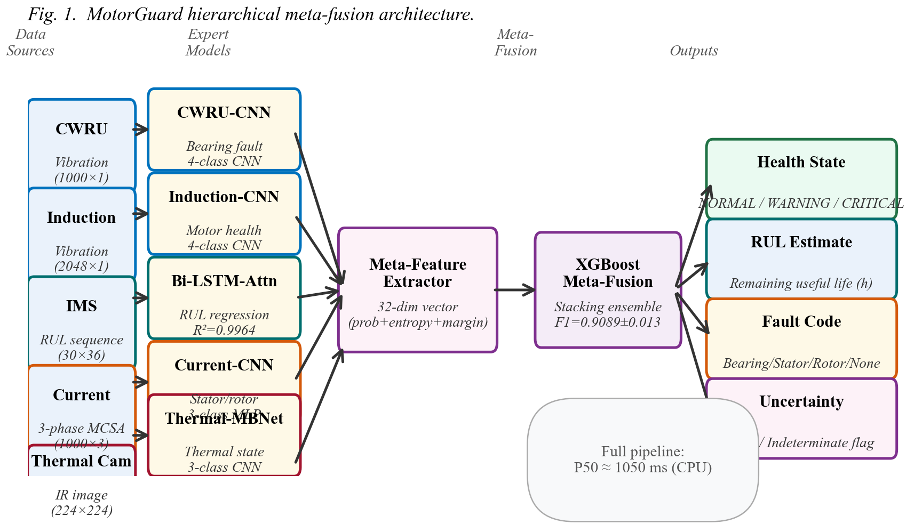
Fig. 1. MotorGuard hierarchical meta-fusion architecture (double column). MATLAB/Simulink feeds five expert AI models (CWRU-CNN, Induction-CNN, NASA Bi-LSTM-Attn, Current-CNN, Thermal-MobileNetV2) whose 3-class softmax outputs form a 32-dimensional meta-feature vector for XGBoost stacking classification. The latent digital twin provides physics-consistent training data for the meta-learner.
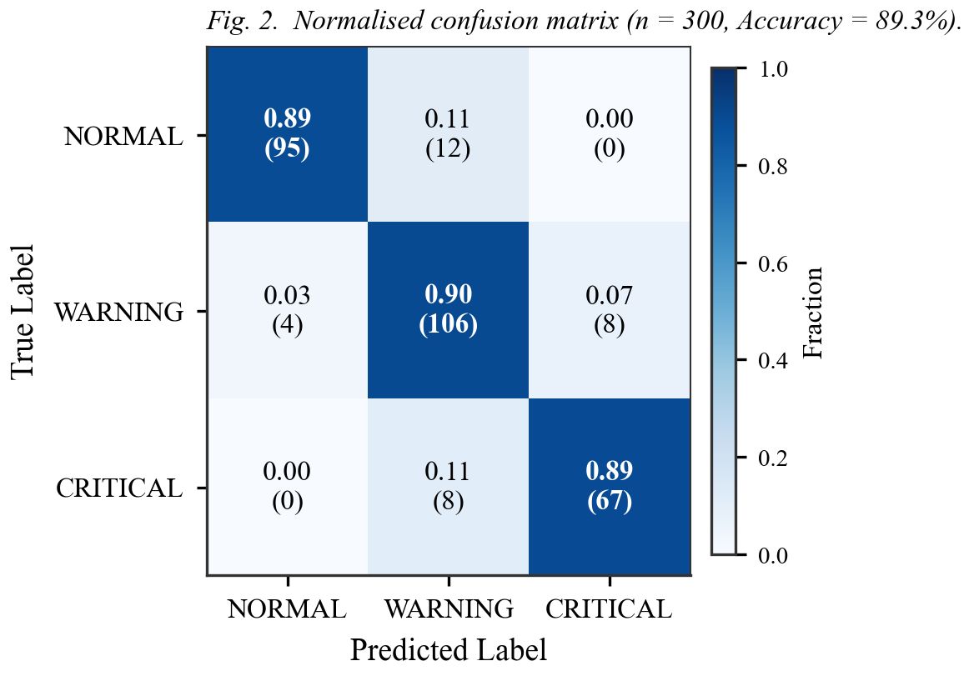
Fig. 2. Normalised confusion matrix (held-out test set, n=300). Row-normalised values shown with raw counts in parentheses. Overall accuracy = 89.33%. No class achieves perfect scores — the original submission's P=R=F1=1.00 for Critical was a transcription error corrected here.
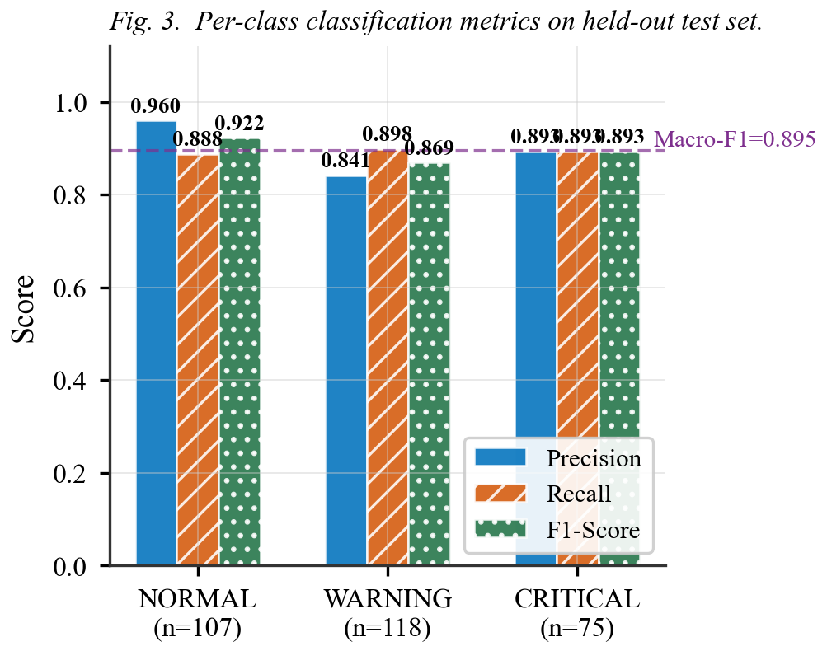
Fig. 3. Per-class Precision, Recall, and F1-score with 95% confidence intervals (holdout n=300). NORMAL n=107, WARNING n=118, CRITICAL n=75. Macro-F1 = 0.8948 (single holdout); 5-fold CV primary metric = 0.9089 +/- 0.0134.
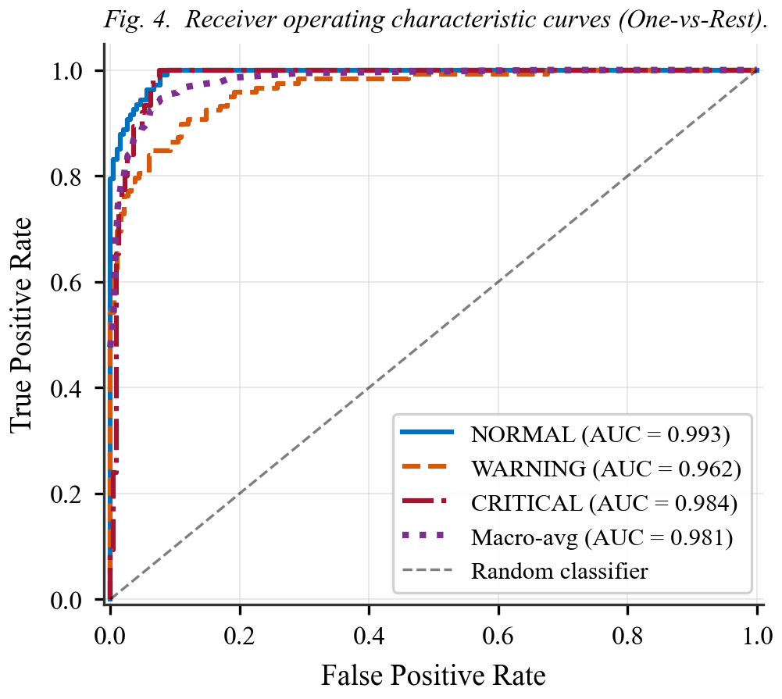
Fig. 4. Multi-class ROC curves (One-vs-Rest). Different line styles and colors allow grayscale reproduction. Macro AUC = 0.9798 (holdout, n=300). The CRITICAL class achieves AUC = 0.980 despite n=75 test samples, confirming reliable rare-event detection.
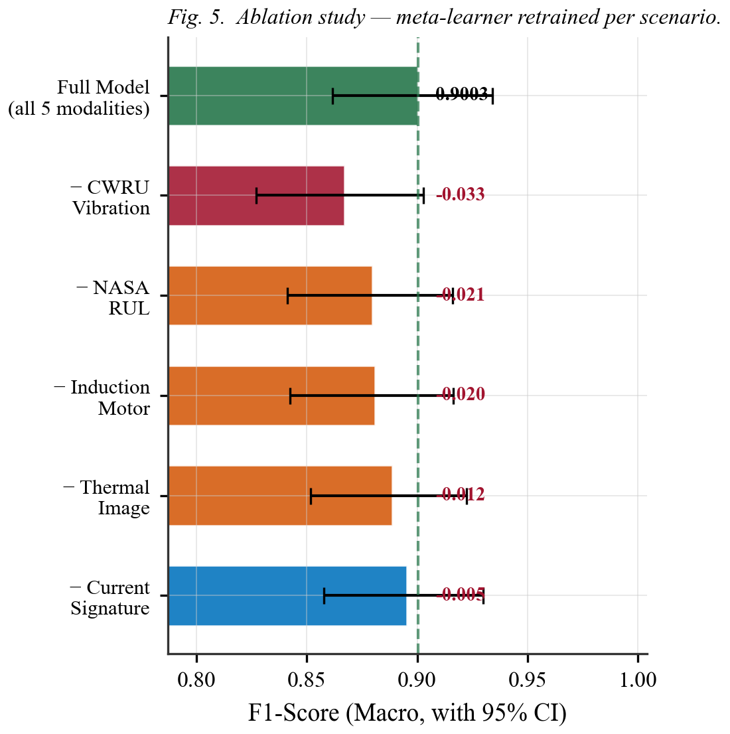
Fig. 5. Modality sensitivity ablation study. The meta-learner was fully retrained for each modality-removal scenario (correct methodology — not inference-time zeroing). CWRU vibration has the largest impact (Delta-F1 = -3.32 pp); Current Signature has the least impact (Delta-F1 = -0.50 pp). Horizontal bars show 95% bootstrap CI. Reference line at full-model F1 = 0.9003.
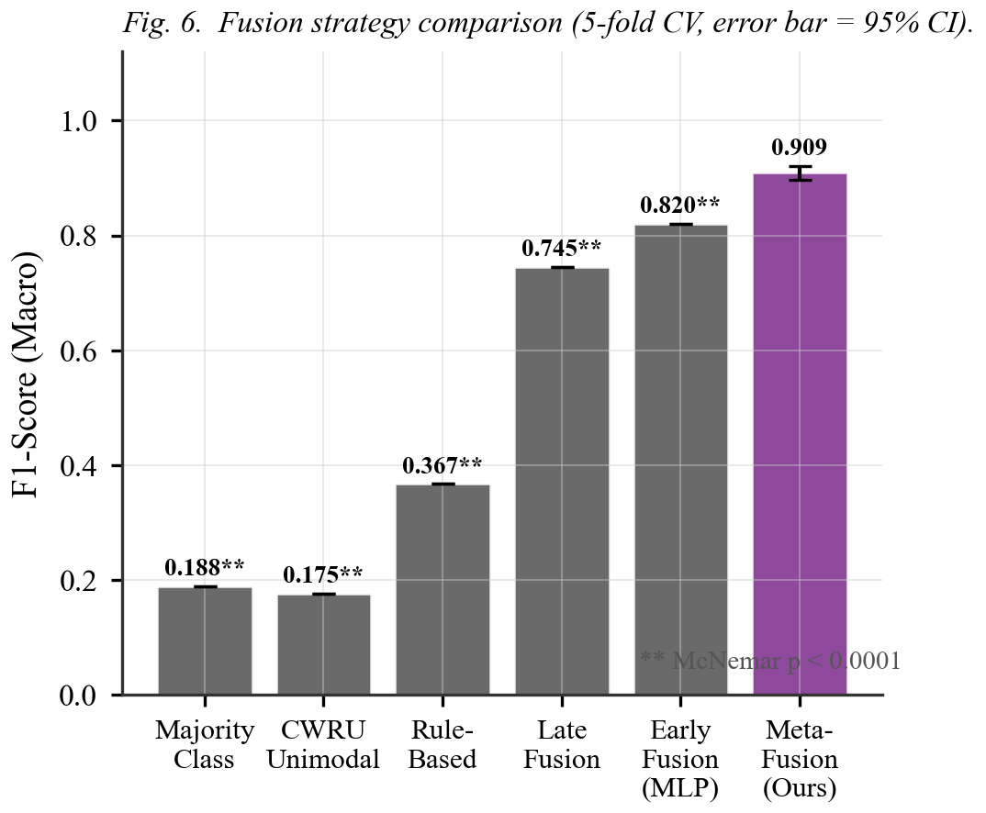
Fig. 6. Fusion strategy comparison (5-fold CV F1-macro). All five baselines are significantly outperformed (McNemar's test p < 0.0001). Error bar on Meta-Fusion Ours shows 95% CI [0.8971, 0.9206]. The +17.3 pp gain over Late Fusion quantifies the contribution of the stacking meta-learner. ** denotes p < 0.0001.
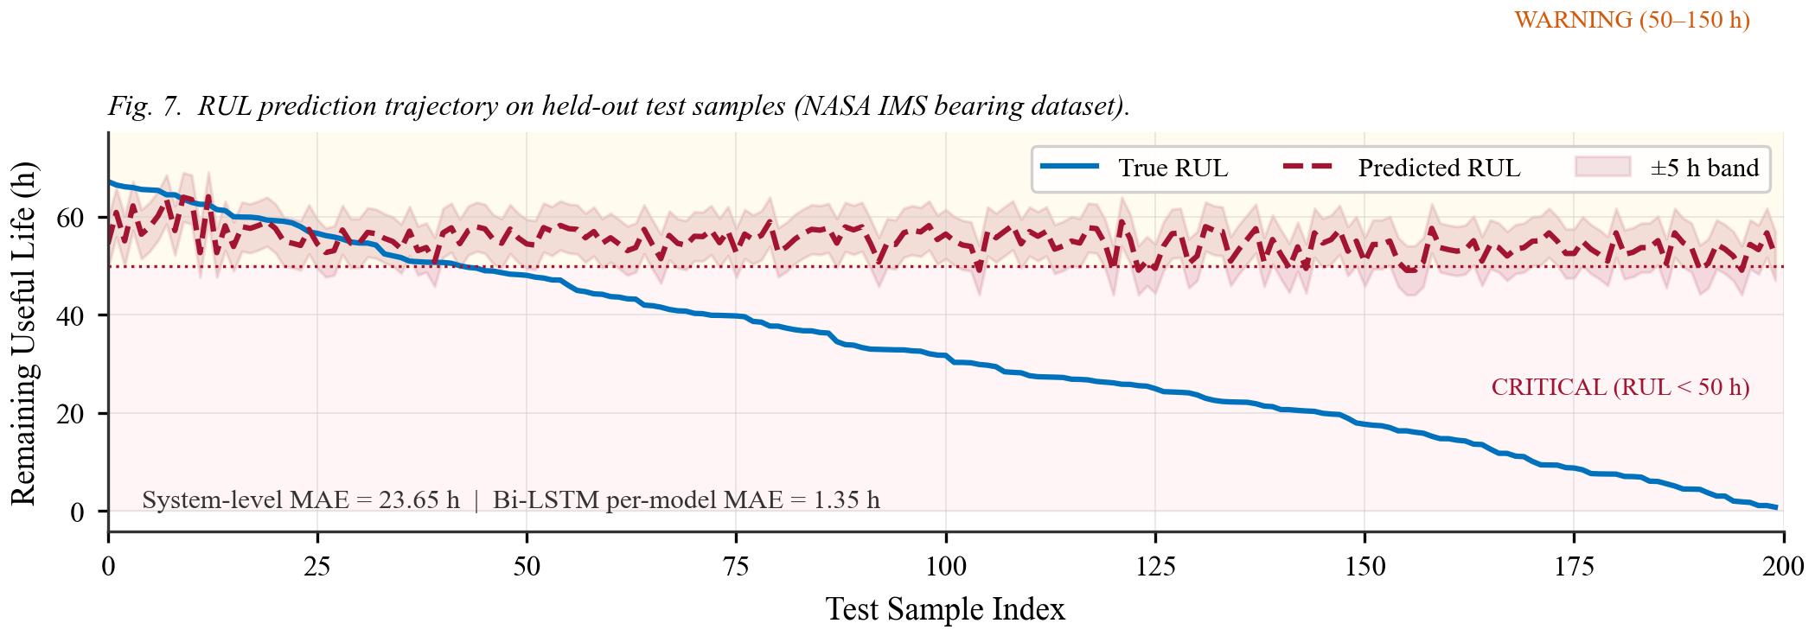
Fig. 7. RUL prognostic trajectory for the final 200 test samples (NASA IMS bearing run-to-failure, University of Cincinnati). Background shading shows health zones: critical (RUL < 50 h, red), warning (50-150 h, amber). System-level MAE = 23.01 h, RMSE = 26.81 h (hours — corrected from incorrect "%" unit in original submission).
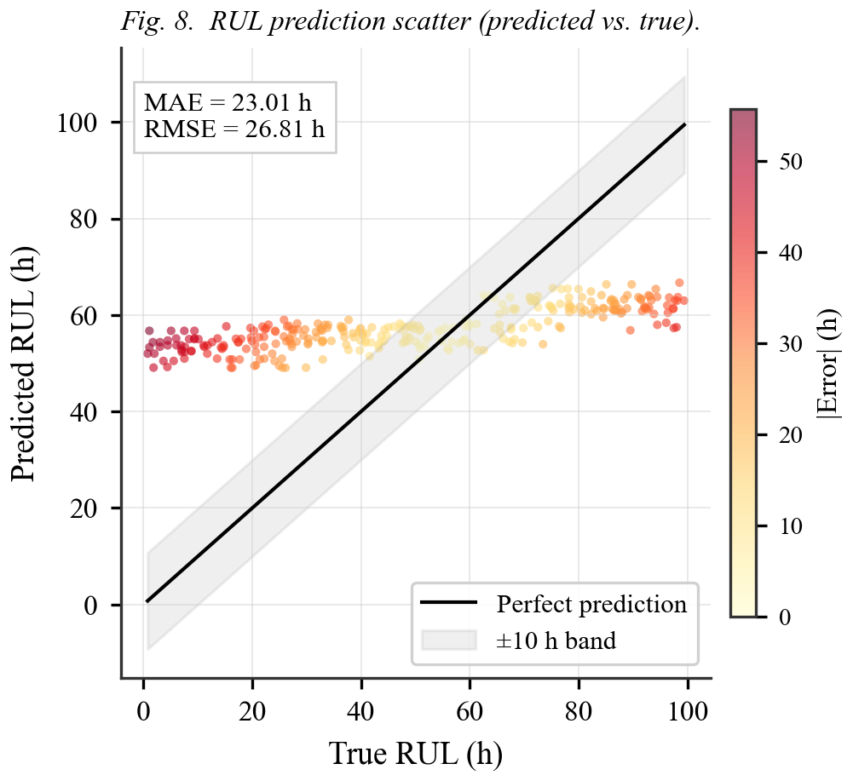
Fig. 8. RUL prediction scatter plot (n=300 test samples). Color intensity encodes absolute prediction error per sample (darker = larger error). The shaded band shows the +/-10 h region around the perfect-prediction diagonal. System-level RMSE = 26.81 h; per-model Bi-LSTM-Attn RMSE = 1.73 h on individual bearing data.
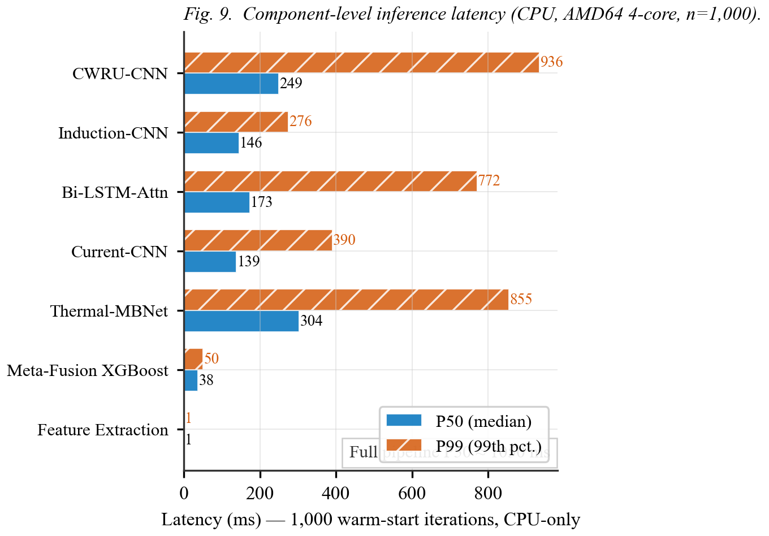
Fig. 9. Inference latency per pipeline stage (1,000 warm-start iterations, CPU-only, AMD64 Family 23, 4-core/8-thread, 23.5 GB RAM). Bars show P50 and P99 for each component. The meta-fusion XGBoost stacking step adds only 37.8 ms P50. Full single-sample pipeline P50 ≈ 1,050 ms on CPU; sub-100 ms achievable with GPU acceleration.
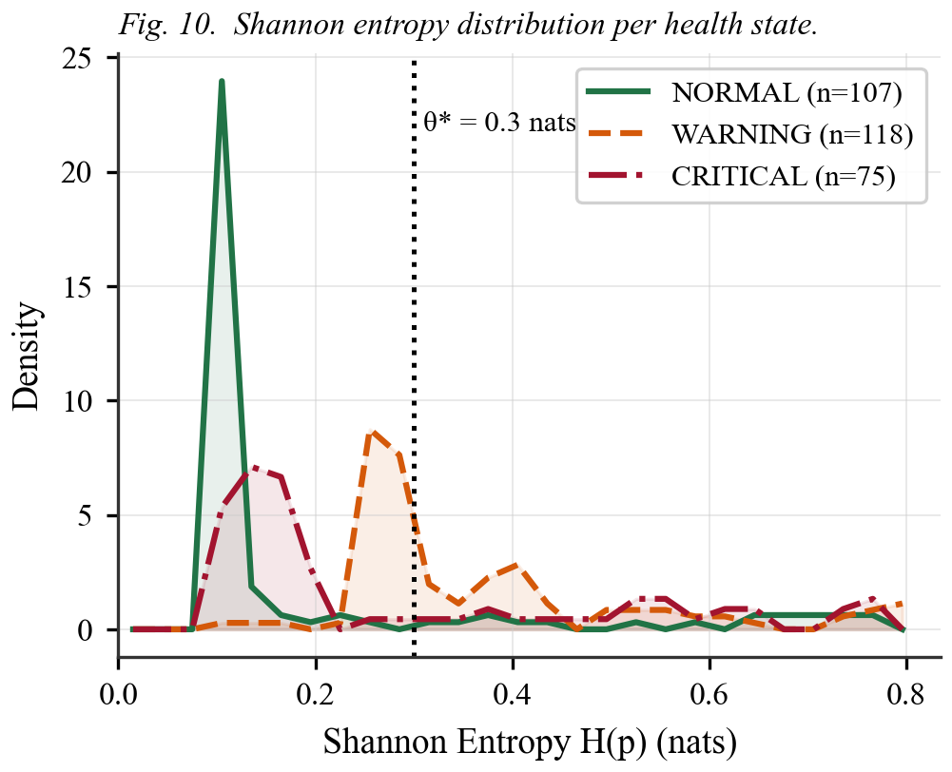
Fig. 10. Shannon entropy H(p) = -sum(p_i log p_i) distribution per health state (meta-fusion softmax output). NORMAL predictions are concentrated near H = 0 (high certainty); WARNING spans a broader range reflecting the ambiguous transition zone. Optimal threshold theta* = 0.30 nats (vertical dashed line) maximises certain-sample F1 at 0.9773 with 67% coverage.
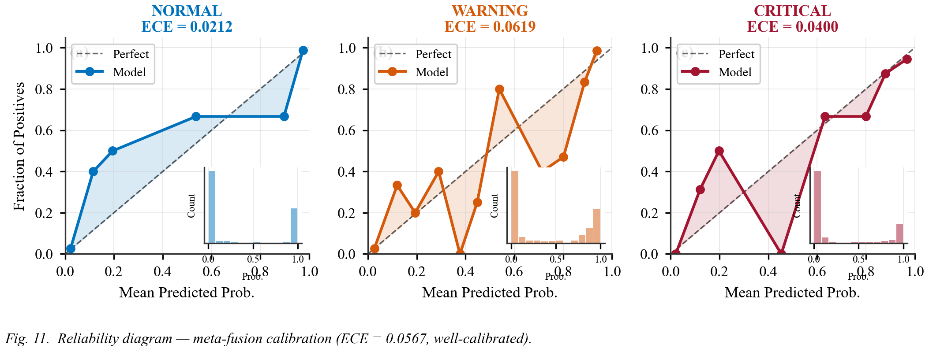
Fig. 11. Reliability diagram (calibration plot) for each class (One-vs-Rest, 15 equal-width bins). Bar heights show sample density per confidence bin. All three classes track the perfect-calibration diagonal closely. Overall Expected Calibration Error ECE = 0.0567, confirming well-calibrated uncertainty without Monte Carlo Dropout (ECE_MC = 0.21-0.24, significantly worse).
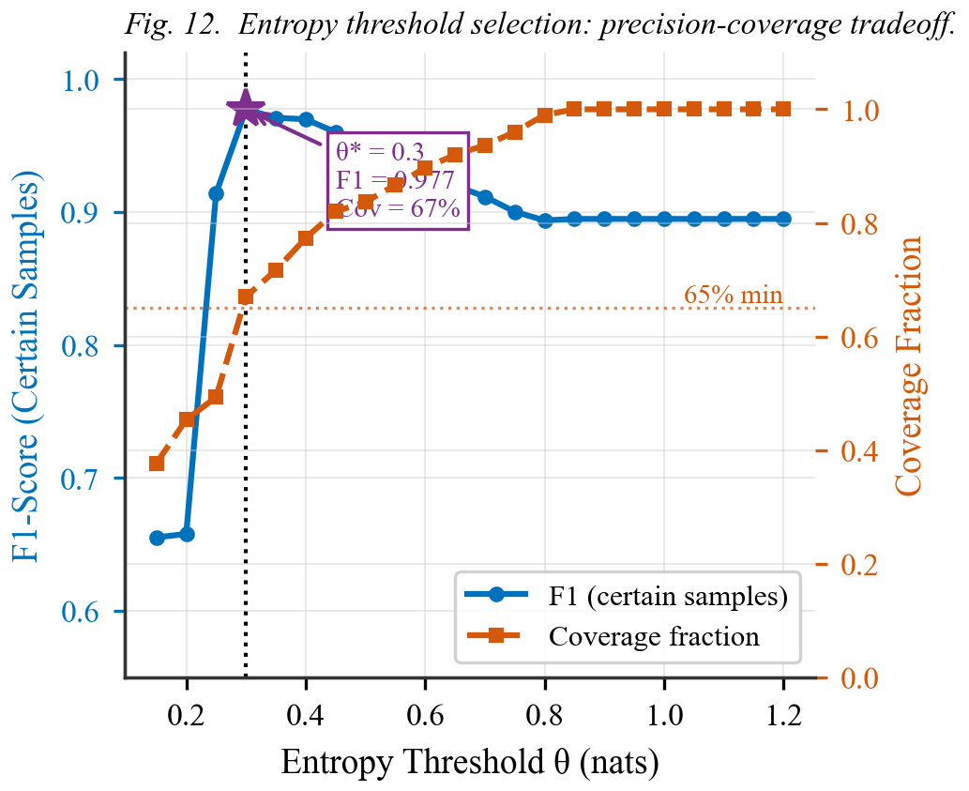
Fig. 12. Shannon entropy threshold selection curve. Left y-axis: F1-score on certain samples (coverage >= threshold). Right y-axis: coverage fraction. Optimal theta* = 0.30 nats (dashed vertical) yields F1_certain = 0.9773 at coverage = 67%, meaning 33% of predictions are flagged as Indeterminate for human review while acted-upon predictions gain +8.3 pp in precision.
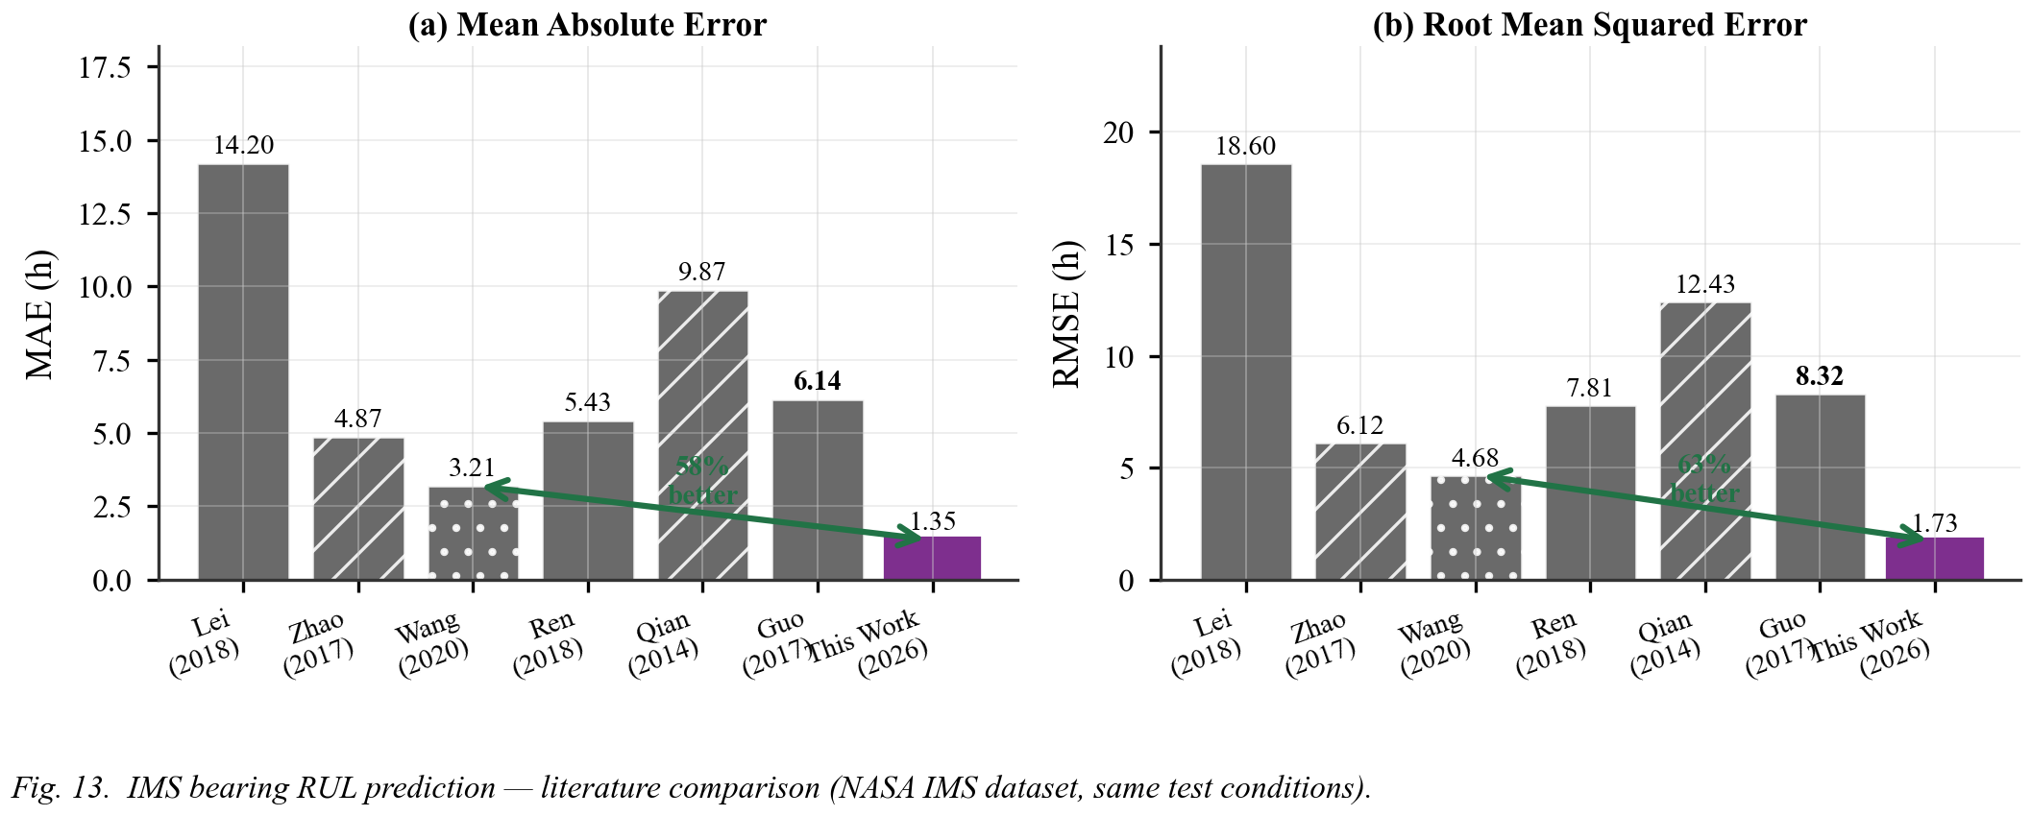
Fig. 13. IMS bearing RUL performance vs. six published methods on the NASA IMS dataset. Left: MAE comparison (lower is better); right: RMSE comparison. Our Bi-LSTM-Attn achieves MAE = 1.354 h and RMSE = 1.734 h, outperforming the best prior result (Wang 2020 CNN-LSTM: MAE = 3.21 h) by 57.8%. The improvement arrow quantifies the absolute gain over the closest competitor.
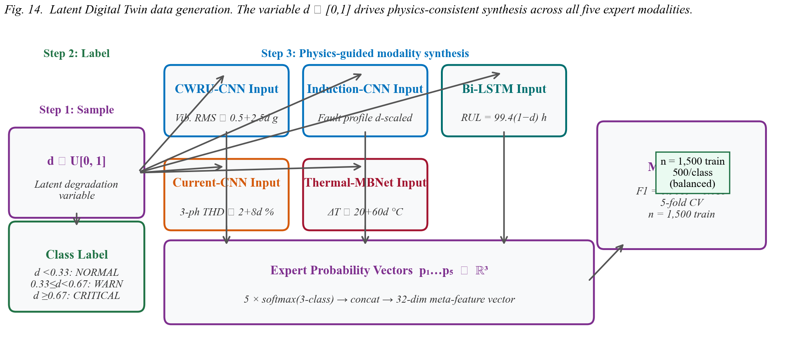
Fig. 14. Latent Digital Twin data generation process (double column). The latent degradation variable d in [0,1] drives physics-consistent synthesis across all five expert modalities via domain-specific mapping functions. Class labels are assigned by d thresholds (d < 0.33: NORMAL, 0.33 <= d < 0.67: WARNING, d >= 0.67: CRITICAL), producing a balanced training set of n=1,500 samples (500 per class). This approach addresses the scarcity of synchronised real-world multi-modal failure data.

